Before starting, make sure:
- Docker Engine is installed → docker --version
- Docker Compose plugin is installed → docker compose version
(Notice: new Docker versions use docker compose not docker-compose)
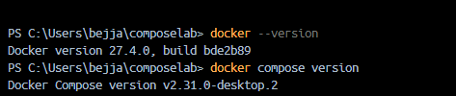
- A working folder where you’ll create all files:
mkdir compose-lab
cd compose-lab
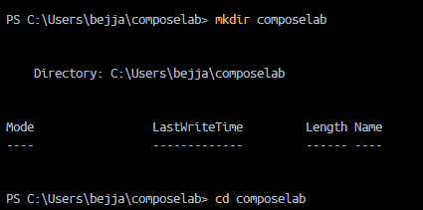
Step 1: Define and run multiple interdependent services
File: docker-compose.yml
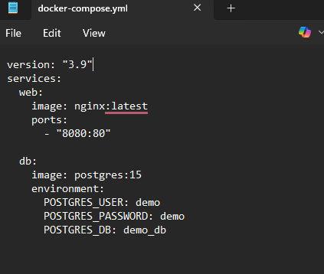
version: "3.9"
services:
web:
image: nginx:latest
ports:
- "8080:80"

db:
image: postgres:15
environment:
POSTGRES_USER: demo
POSTGRES_PASSWORD: demo
POSTGRES_DB: demo_db
Run:
docker compose up -d
Check services:
docker compose ps
Verify in browser:
This time it should pull nginx and postgres images (if not already downloaded).
http://localhost:8080 → Nginx Welcome Page.
✅ Output:
- Web page shows "Welcome to nginx!", db container runs in background.


Step 2: Write and interpret docker-compose.yml files
Now add Redis service.
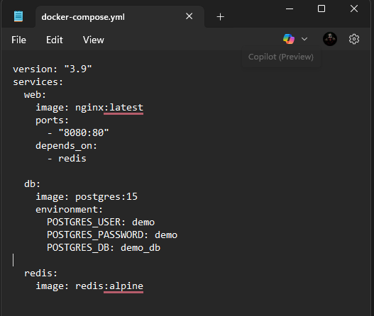
Update docker-compose.yml:
version: "3.9"
services:
web:
image: nginx:latest
ports:
- "8080:80"
depends_on:
- redis

db:
image: postgres:15
environment:
POSTGRES_USER: demo
POSTGRES_PASSWORD: demo
POSTGRES_DB: demo_db

redis:
image: redis:alpine
Run again:
docker compose up -d
docker compose ps
✅ Output:
- Three services (web, db, redis) are listed as running.
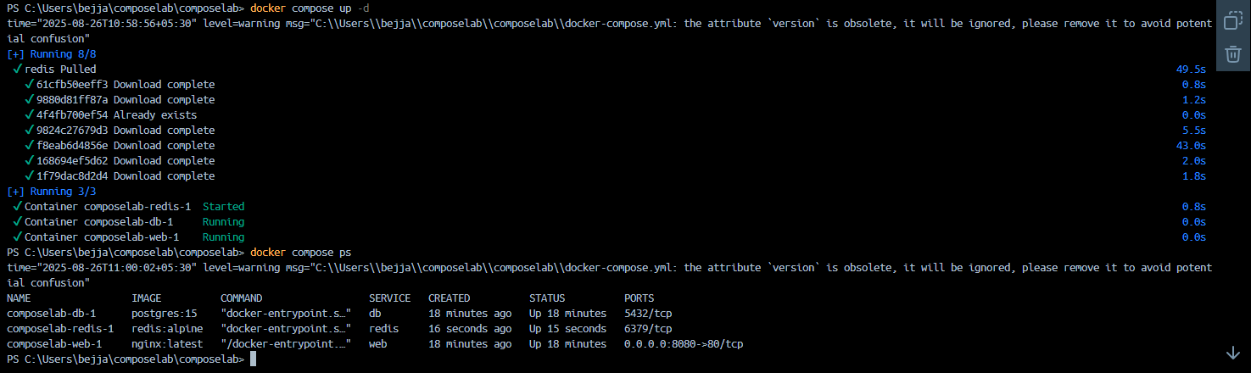

Step 3: Deploy across different machines
- Zip your project:
- cd ..
- zip -r compose-lab.zip compose-lab/
- Copy to another machine (via pendrive, email, SCP).
- On target machine:
- unzip compose-lab.zip
- cd compose-lab
- docker compose up -d
✅ Output: Same services (nginx + postgres + redis) run without any extra setup.
You already created a project folder (let’s say compose-lab) on your computer that contains:
- docker-compose.yml
Now, Step 3 says: “Zip your compose-lab folder and move it to another machine.”
That means we want to copy the entire project folder to another computer with Docker installed, so the same services can run there without editing anything.

🗂️ Folder structure
Let’s assume you made your folder like this on your computer:
C:\Users\vysha\OneDrive\Desktop\SE Lab\compose-lab\
└── docker-compose.yml
Later this folder may also contain:
compose-lab/
├── docker-compose.yml
├── app.py
└── Dockerfile
👉 The whole compose-lab folder is what you need to zip.

📝 Step-by-Step Instructions
On your first machine (your PC):
- Go to the folder where compose-lab is located:
- C:\Users\vysha\OneDrive\Desktop\SE Lab\
- Right-click on compose-lab → Send to → Compressed (zipped) folder
This creates compose-lab.zip.
Now you have:
compose-lab.zip

Transfer to the other machine
Move compose-lab.zip to the second machine (via USB, email, Google Drive, etc.).

On the second machine:
- Place the zip anywhere (e.g., Desktop).
- Extract it → you’ll get the same folder:
- C:\Users\OtherUser\Desktop\compose-lab\
- └── docker-compose.yml
- Open a terminal (PowerShell / CMD / Linux shell) and go inside that folder:
- cd Desktop/compose-lab
- Run:
- docker compose up -d
(Make sure Docker Desktop is installed and running on that machine too!)

✅ Expected Result
- On the second machine, Docker will pull the images (nginx, postgres, etc.).
- Same services (web, db, and redis if you added it) will start.
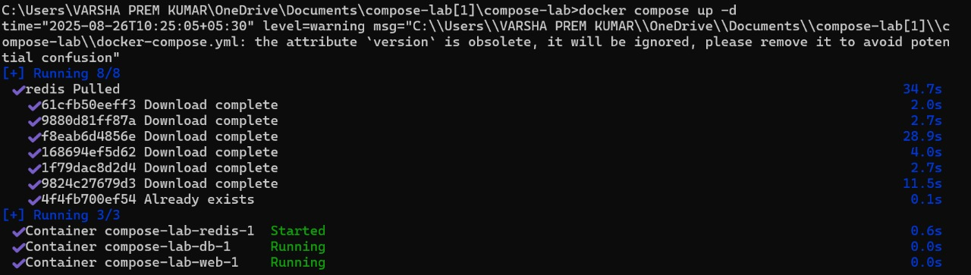
- You can open http://localhost:8080 on the second machine and see the same Nginx welcome page.
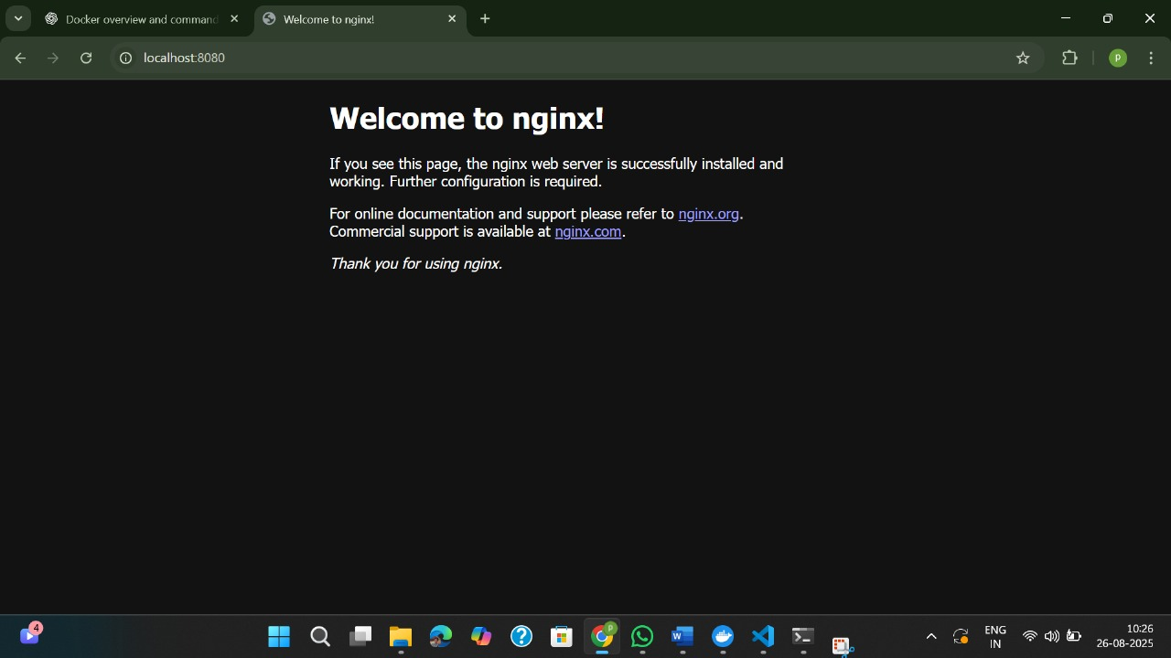
Step 4: Networking and persistent storage
Update docker-compose.yml:
services:
web:
image: nginx:latest
ports:
- "8080:80"
networks:
- app-net
depends_on:
- db

db:
image: postgres:15
environment:
POSTGRES_USER: demo
POSTGRES_PASSWORD: demo
POSTGRES_DB: demo_db
volumes:
- db-data:/var/lib/postgresql/data
networks:
- app-net

networks:
app-net:

volumes:
db-data:Run:
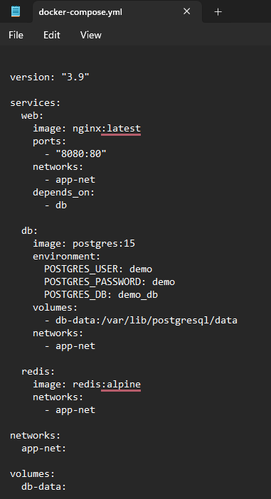
docker compose up -d /docker compose up
Expected Output:
[+] Running 3/3
✔ Network compose-lab_app-net Created
✔ Volume "compose-lab_db-data" Created
✔ Container compose-lab-db-1 Started
✔ Container compose-lab-web-1 Started
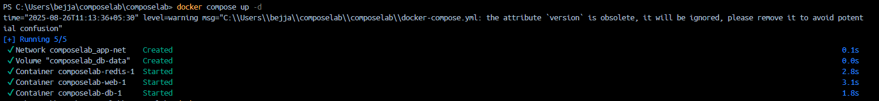
3. Insert sample data into Postgres
First, get container name:
docker compose ps
✅ Expected Output (example):
NAME IMAGE COMMAND SERVICE STATUS PORTS
compose-lab-web-1 nginx:latest "/docker-entrypoint.…" web running 0.0.0.0:8080->80/tcp
compose-lab-db-1 postgres:15 "docker-entrypoint.s…" db running 5432/tcp
Enter the db container:
docker exec -it compose-lab-db-1 bash
Run psql:
psql -U demo -d demo_db
✅ Expected Output:
psql (15.x)
Type "help" for help.

demo_db=#
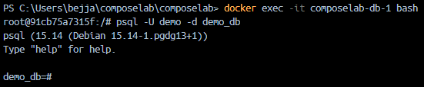
Insert and view data:
CREATE TABLE students (id SERIAL PRIMARY KEY, name VARCHAR(50));
INSERT INTO students (name) VALUES ('Alice'), ('Bob'), ('Charlie');
SELECT * FROM students;
✅ Expected Output:
CREATE TABLE
INSERT 0 3
id | name
----+---------
1 | Alice
2 | Bob
3 | Charlie
(3 rows)
Exit Postgres:
\q
Exit container:
Exit
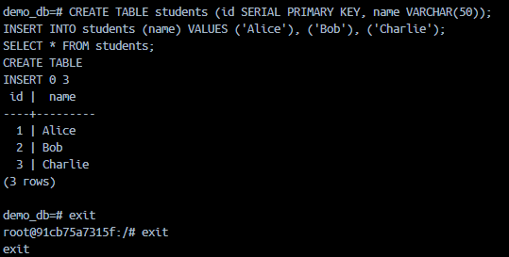

📝 4. Stop containers
docker compose down
✅ Expected Output:
[+] Running 2/2
✔ Container compose-lab-web-1 Removed
✔ Container compose-lab-db-1 Removed
✔ Network compose-lab_app-net Removed
⚠️ Notice: Volume db-data is NOT removed.
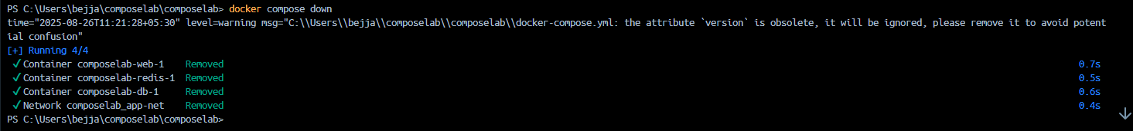

📝 5. Start containers again
docker compose up -d
✅ Expected Output:
[+] Running 2/2
✔ Container compose-lab-db-1 Started
✔ Container compose-lab-web-1 Started
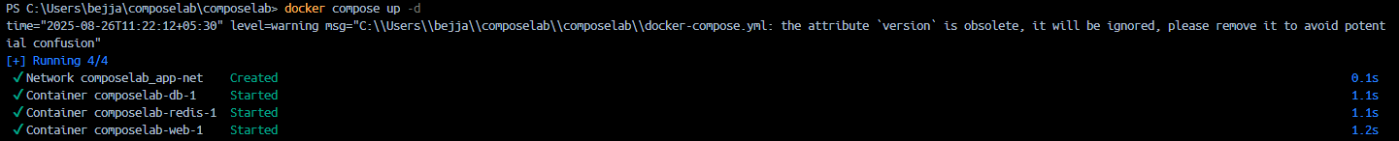

📝 6. Verify data persistence
Check the table again (direct command without opening bash):
docker exec -it compose-lab-db-1 psql -U demo -d demo_db -c "SELECT * FROM students;"
✅ Expected Output:
id | name
----+---------
1 | Alice
2 | Bob
3 | Charlie
(3 rows)
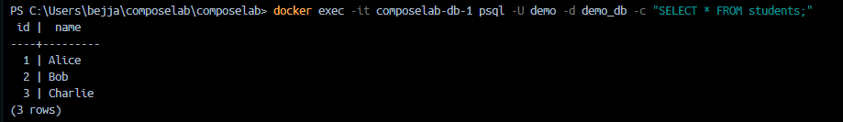

Step 5: Faster iteration during development
Create a Flask App:
File: app.py
from flask import Flask
app = Flask(__name__)

@app.route("/")
def home():
return "Hello from Flask + Docker!"

if __name__ == "__main__":
app.run(host="0.0.0.0", port=5000)
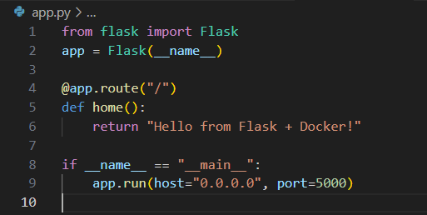
File: Dockerfile
FROM python:3.10-slim
WORKDIR /app
COPY app.py /app/
RUN pip install flask
CMD ["python", "app.py"]
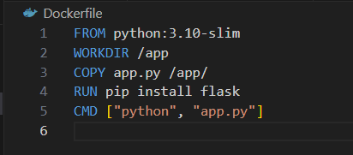
Update docker-compose.yml:
version: "3.9"

services:
web:
build: .
ports:
- "5000:5000"
depends_on:
- db

db:
image: postgres:15
environment:
POSTGRES_USER: demo
POSTGRES_PASSWORD: demo
POSTGRES_DB: demo_db
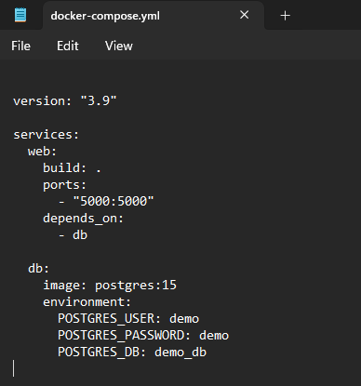
Run:
docker compose up --build
Visit → http://localhost:5000
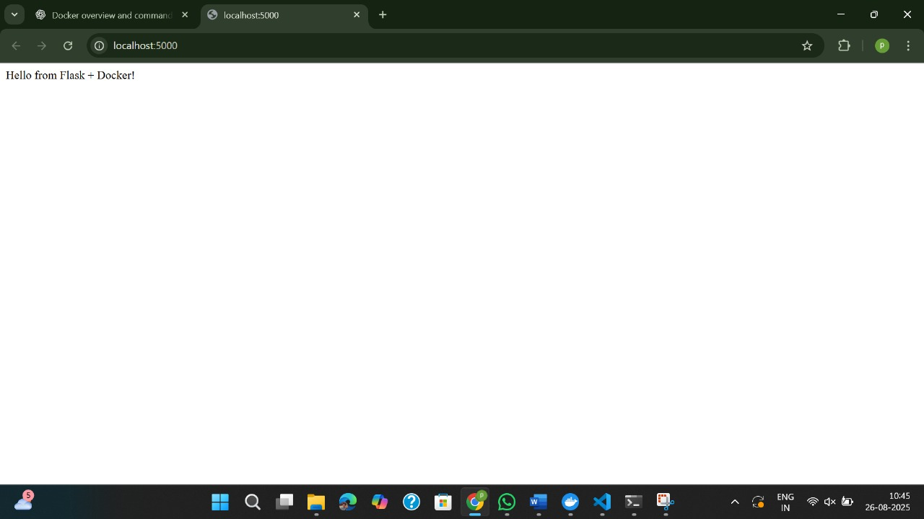
Change app.py message → rerun docker compose up --build
✅ Output: New message appears immediately after rebuild.
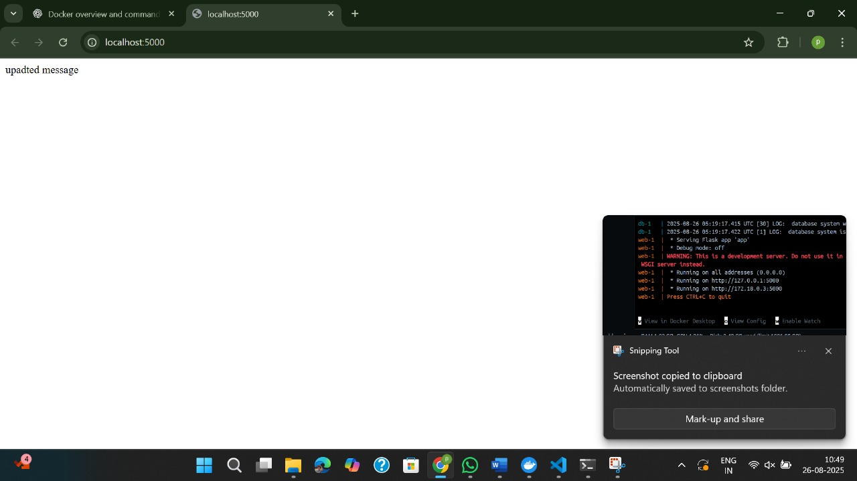

Scenario based Questions:
1. You have two applications — a Node.js backend and a Python script that handles scheduled jobs. You're considering running both inside the same container. Should you run multiple applications in the same Docker container?
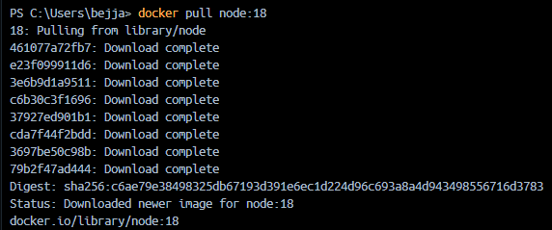
2. You have a Flask API and an Nginx server. You want to run both containers on the same host and expose them on ports 5000 and 80 respectively. How can you expose both applications from different containers?
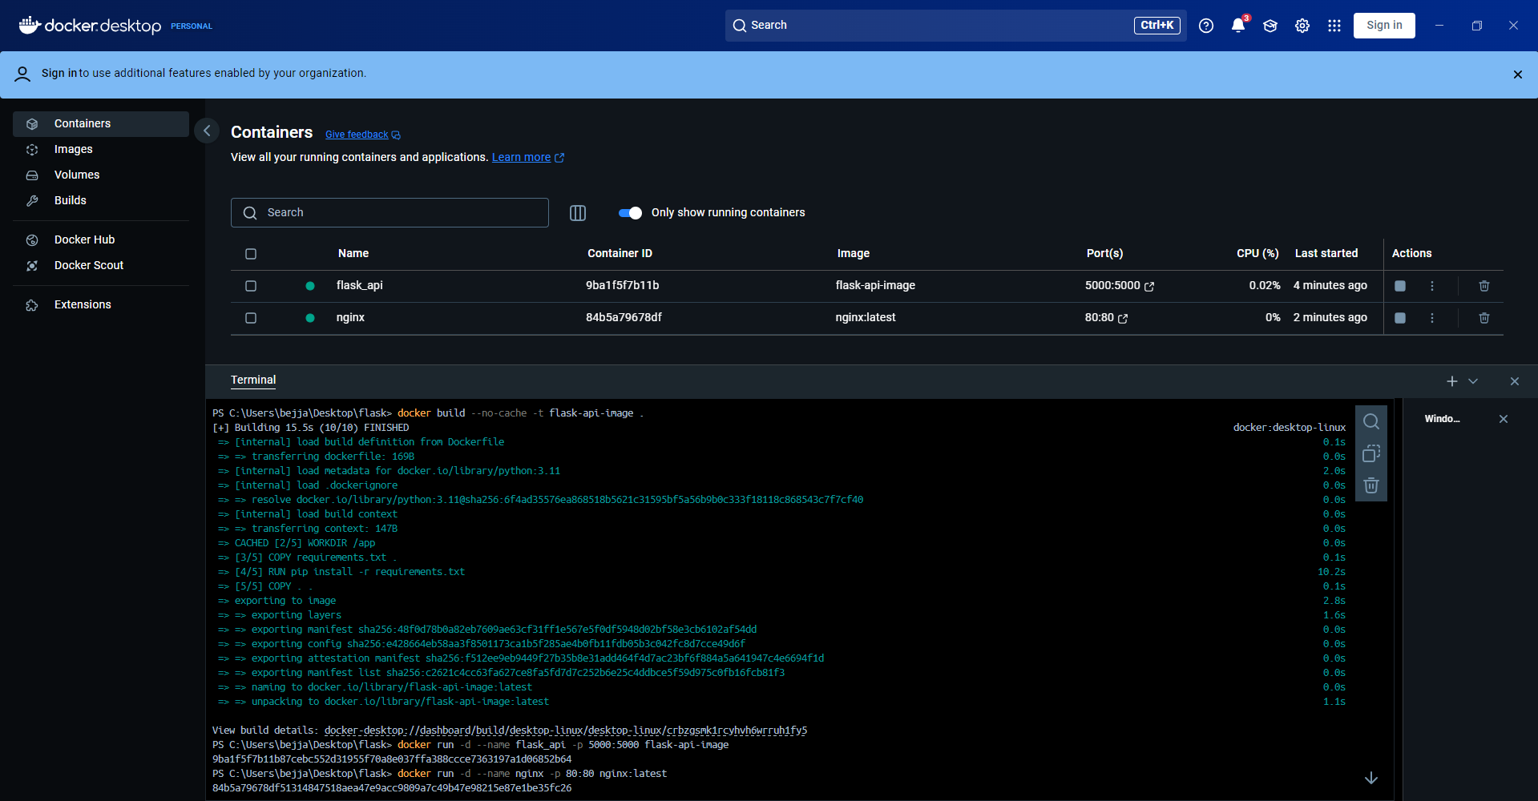

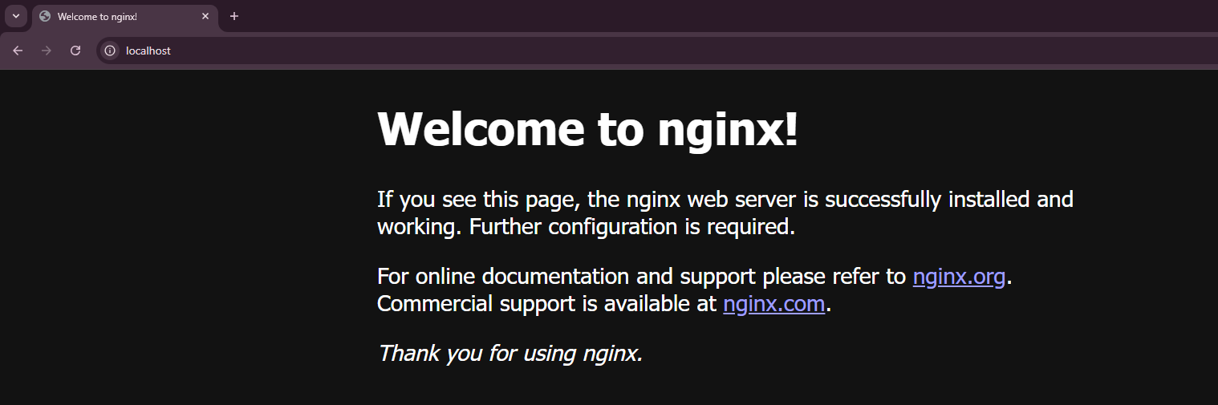
3. You want to run a React frontend, an Express.js backend and MongoDB – all together.
How do you run and manage all three together?
4. You try to run two containers that both expose port 8080 on the host.
What happens, and how can you run both apps?

5. You updated some code and want to restart your frontend, backend, and DB containers quickly. What is the easiest way to restart all services?
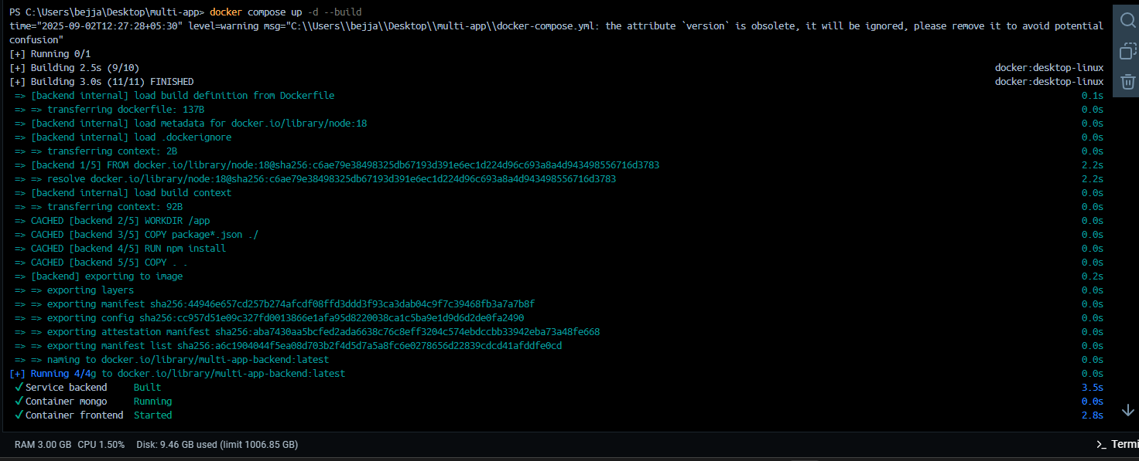
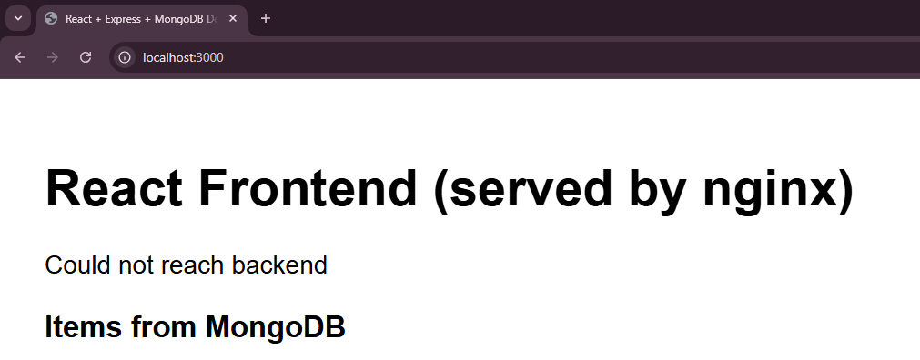
6. Your frontend has a new release, but you don’t want to restart the backend or DB.
How can you update and rebuild only the frontend container?
7. Tomcat is listening on port 8080, but you get a "Connection Refused" error in the browser. Why?
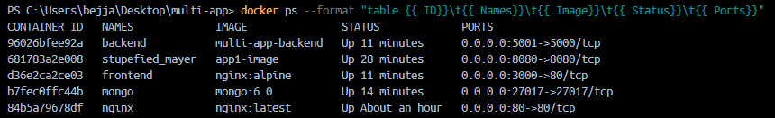
8. You're not sure which container is using port 3000. How do you check?
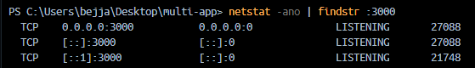
9. How do you stop and clean up your running Tomcat container and image?
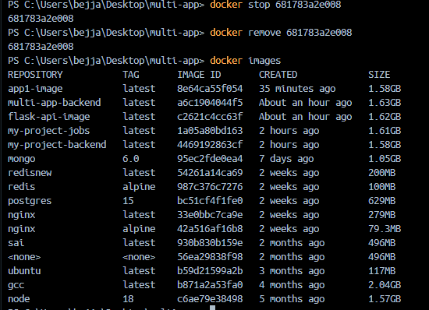
10.You want to share your app with a teammate. What do you do with the Docker image?

